1. Introduction
The effective DR plan is an essential element of business continuity management, especially in the field of banking where failure of the system – even momentarily – can lead to losses that can be financially and legally costly and may cause permanent damage to reputation. This part of the project highlights a work breakdown structure and the related Gantt chart for implementing the IT Disaster Recovery Plan for the banking system. The project involves five stages: Assessment, Planning, Implementation, Testing, and Maintenance. Each stage entails several activities that have identified responsible parties, estimated duration, and dependency among themselves.

2. Work Breakdown Structure (WBS)
In this regard, the WBS breaks down the IT Disaster Recovery Project into a hierarchical breakdown of manageable work packages. Every one of the five phases stands out as one distinct phase of the DR process cycle; these phases are further divided into individual, actionable items within that particular phase.
Phase | Task ID | Task Name | Owner | Duration
Assessment | A1 | Risk & Threat Assessment | Risk Manager | 5 days
Assessment | A2 | BIA – Critical Systems Mapping | IT Director | 5 days
Assessment | A3 | RTO / RPO Target Setting | CTO | 3 days
Planning | P1 | DR Strategy Design | IT Director | 6 days
Planning | P2 | Resource & Budget Planning | Project Manager | 4 days
Planning | P3 | Vendor & SLA Negotiations | Procurement Lead | 5 days
Planning | P4 | DR Policy & Procedure Drafting | Compliance Officer | 4 days
Implementation | I1 | Backup Infrastructure Setup | Systems Engineer | 7 days
Implementation | I2 | Failover Systems Configuration | Network Engineer | 6 days
Implementation | I3 | Data Replication Deployment | Database Admin | 5 days
Implementation | I4 | Staff DR Training Programme | Training Lead | 4 days
Testing | T1 | Tabletop Exercise | DR Coordinator | 3 days
Testing | T2 | Partial Failover Simulation | Systems Engineer | 5 days
Testing | T3 | Full DR Drill | IT Director | 5 days
Testing | T4 | Gap Analysis & Remediation | Risk Manager | 4 days
Maintenance | M1 | DR Plan Documentation | Compliance Officer | 4 days
Maintenance | M2 | Monitoring & Alert Setup | Network Engineer | 5 days
Maintenance | M3 | Scheduled Annual Review | IT Director | 3 days

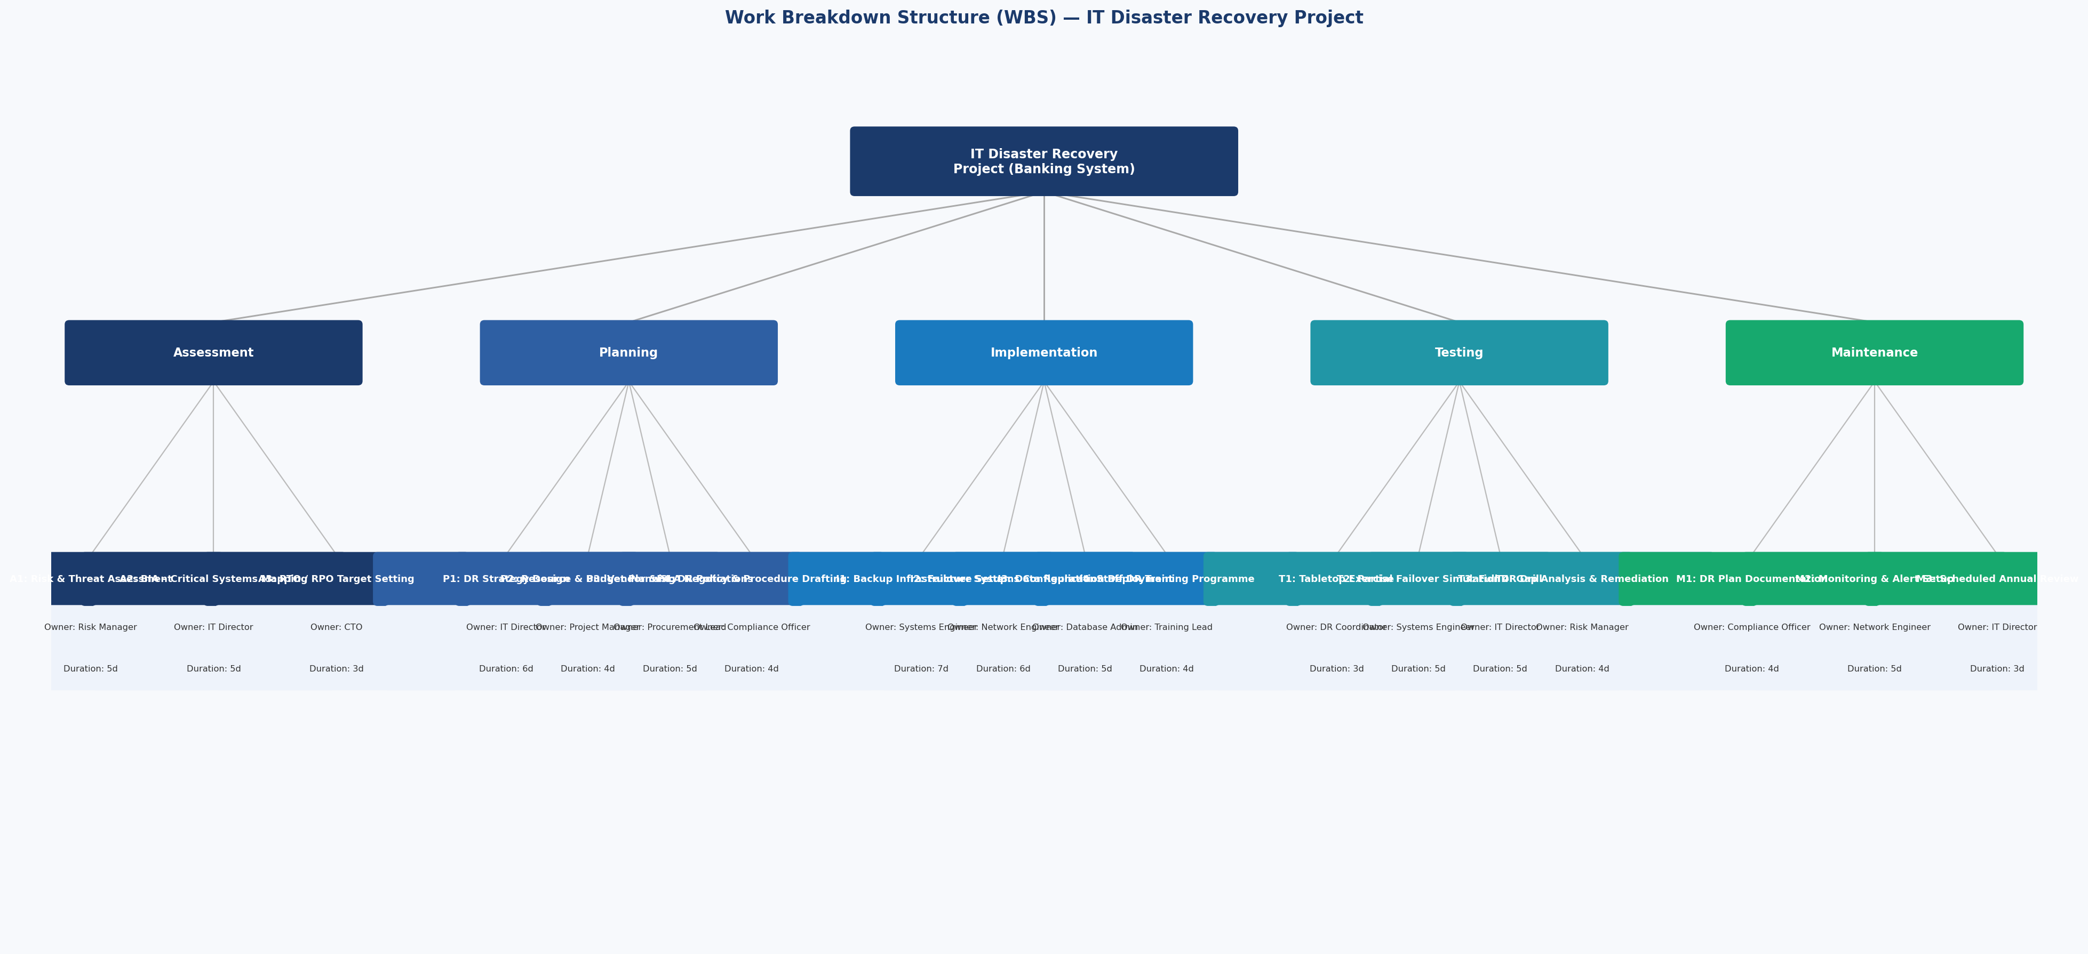
Figure 1: Work Breakdown Structure (WBS) — IT Disaster Recovery Project (Banking System)

3. Gantt Chart & Task Interdependencies
This is a Gantt chart for all eighteen tasks in five different phases in relation to the timeline consisting of 60 working days, which translates to about 12 weeks. Tasks have been color coded according to their phase, and there are dependency arrows to show the dependence relationship of tasks. This makes it easier for project managers to determine the critical path, resource constraints, and progress in relation to benchmark dates.

All the tasks are in accordance with the finish-to-start dependency rule — the next task cannot start until the previous task is completed. Dependency relationship examples are that all tasks under Assessment have to be completed before moving on to the Design of DR Strategy; Infrastructure Setup has to precede both Failover Configuration and Data Replication; and all implementation tasks have to be completed before commencing any testing phase tasks.
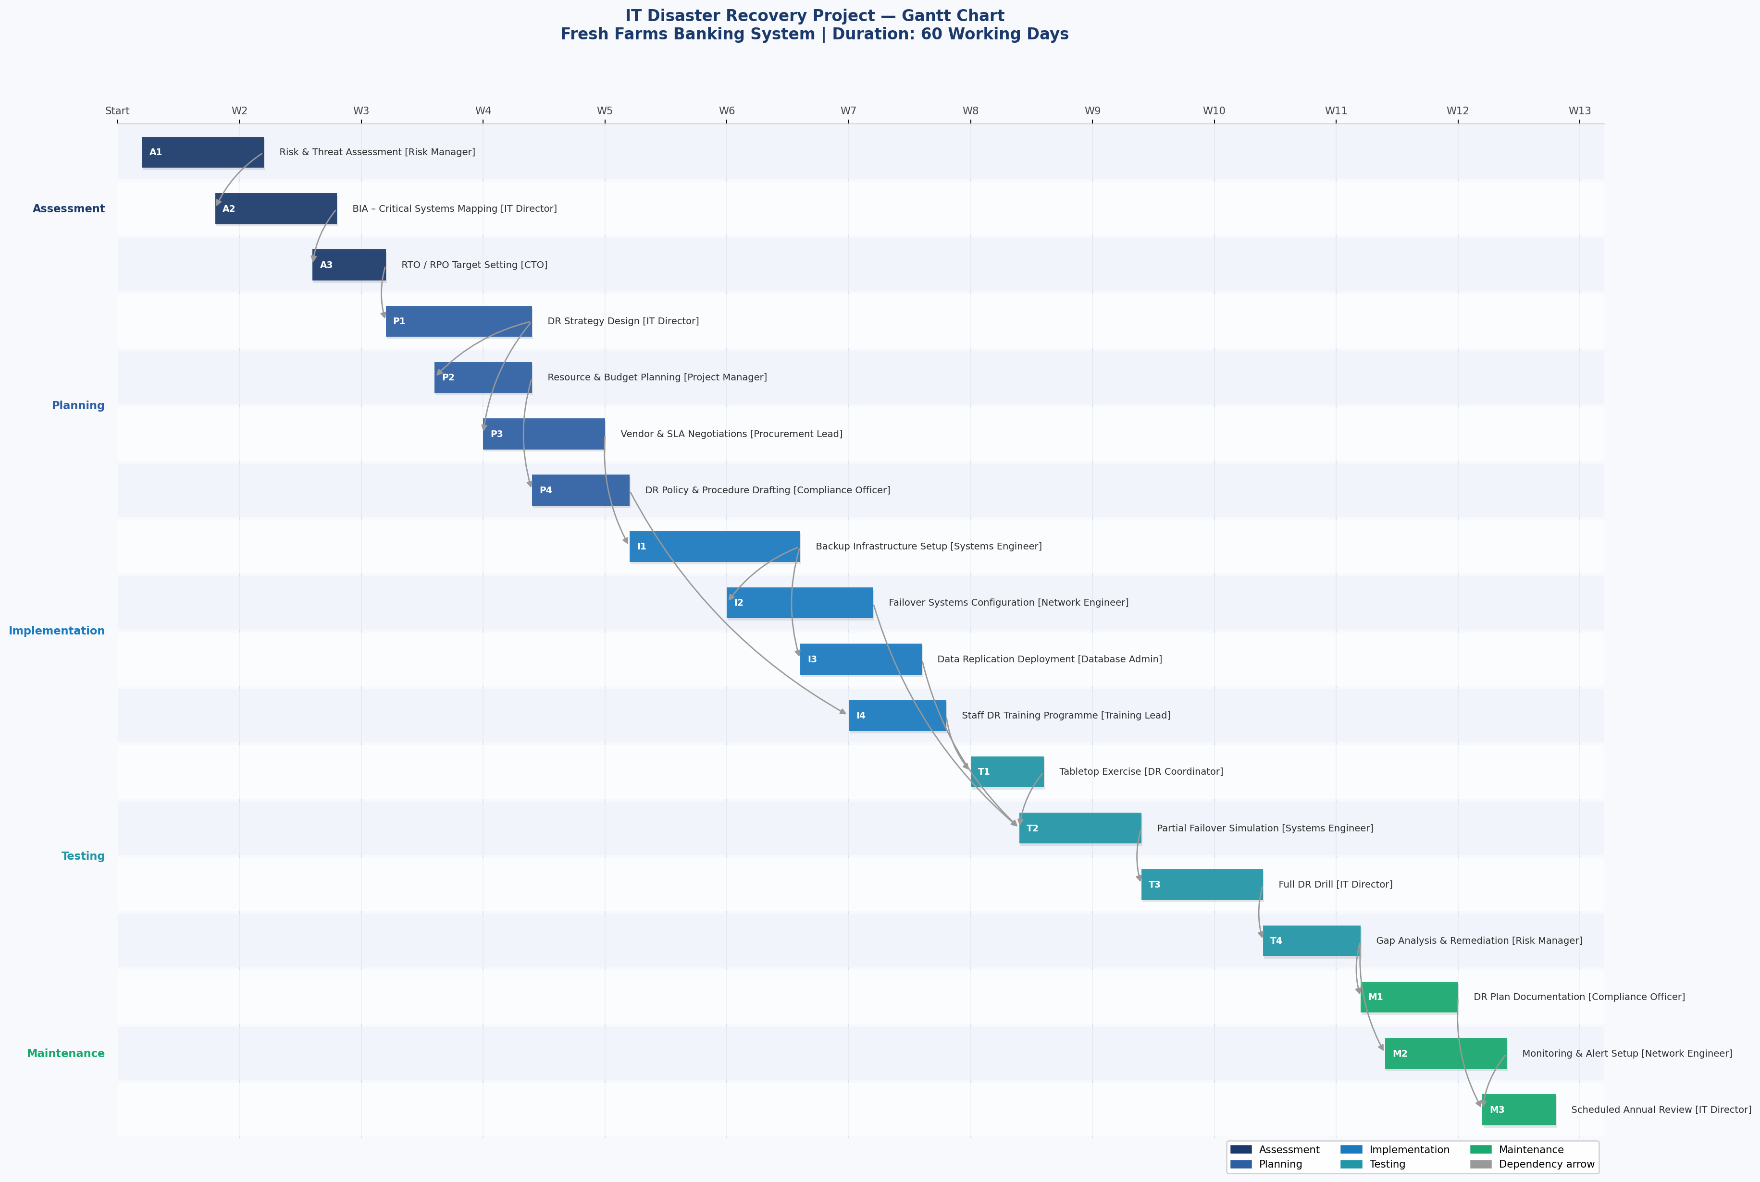
Figure 2: Gantt Chart — IT Disaster Recovery Project | 60 Working Days | Arrows indicate task dependencies

4. Interdependency Analysis
Task interdependencies are a defining feature of any DR project and must be carefully managed to prevent schedule slippage. The following critical dependency chains have been identified:

- Assessment Chain (A1 → A2 → A3): The risk assessment must precede the Business Impact Analysis (BIA), as threat data informs which systems are classified as critical. RTO and RPO targets cannot be set meaningfully without a completed BIA. Any delay in A1 propagates directly to all downstream phases.
- Planning to Implementation (A3 → P1 → P3 → I1): The DR strategy must be finalized before vendor negotiations commence, and infrastructure cannot be procured or deployed until SLAs are in place. This chain represents the primary critical path of the project.
- Parallel Implementation Streams (I1 → I2 and I1 → I3): Once backup infrastructure is established, failover configuration and data replication can proceed concurrently, reducing the overall project duration. These parallel tracks require careful resource scheduling to avoid engineer conflicts.
- Testing Gate (I2 + I3 + T1 → T2): The partial failover simulation is contingent on the completion of both technical implementation streams and the tabletop exercise. This gate ensures that staff are adequately prepared before live system testing commences.
- Maintenance Entry (T4 → M1 + M2): Post-drill gap analysis must be completed before documentation is finalized and monitoring systems are configured, ensuring that all identified deficiencies are captured in the operational DR plan.

5. Conclusion
The proposed WBS and Gantt Chart are operationally sound and serve to provide an organized and transparent basis for the IT DR project being carried out in a banking context. Decomposing the project into five distinct phases and defining interdependences allows for an efficient governance and risk management process for the entirety of the project duration. A period of 60 days is a realistic goal assuming no issues arise along the critical path – Assessment to Infrastructure Implementation. It is imperative that other tasks in Implementation and Maintenance phases are not held up. Following the proposed approach is consistent with global standards for DR management, such as ISO 22301 (Business Continuity Management) and NIST SP 800-34 (Contingency Planning Guide for Federal Information Systems), both applicable to banking/financial service companies.

References
- National Institute of Standards and Technology, “NIST SP 800-34 Rev. 1: Contingency Planning Guide for Federal Information Systems,” NIST, 2010. https://csrc.nist.gov/publications/detail/sp/800-34/rev-1/final
- International Organization for Standardization, “ISO 22301:2019 — Business Continuity Management Systems,” ISO, 2019.
- https://www.iso.org/standard/75106.html
- R. Snedaker, Business Continuity and Disaster Recovery Planning for IT Professionals, 2nd ed. Syngress/Elsevier, 2013.
- Project Management Institute, A Guide to the Project Management Body of Knowledge (PMBOK® Guide), 7th ed. PMI, 2021.

